

Assignment 2:

*Heuristic Evaluation of Autotrader.ca*



Prepared For:  
Professor Fadi Malek

In accordance to the requirements of:

SEG3125 Spring/Summer 2018  
Due: Sunday, June 10th, 2018

Prepared By:

Nicolas Paré (7084451)

Mahyar Gorji (8135109)

Parastoo Saharkhiz (8697886)

Abstract:

Shortly after the completion and submission of assignment one, our team was tasked with a heuristic evaluation of a user interface (herein referred to as ‘UI’) of our choosing. Seeing as how we were already familiar with Autotrader website and its design flaws, we decided to continue to use its UI and adapt our evaluation process to categorize and describe these design flaws.

Included in this report are screen captures of heuristic violations, as well as the violation category they fall into, alphanumeritized via the same method as the powerpoint slides in class. See below for the complete list discussed in lectures:

H2-1: Visibility of system status

H2-2: Match between system and real world

H2-3: User control and freedom

H2-4: Consistency & standards

H2-5: Error prevention

H2-6: Recognition rather than recall

H2-7: Flexibility and efficiency of use

H2-8: Aesthetic and minimalist design

H2-9: Help users recognize, diagnose, and recover from errors

H2-10: Help and documentation

The goal, while wishing to remain precise, is to showcase some major violations and some more minor violations, as will be shown with each violation’s severity rating. In the interest of time and academic commitments, our group will **not** showcase each and every violation that is possible to be found on Autotrader.

# **Table Of Contents**

**Table Of Contents** **2**

**Issue 1: Adblock Changes Jumbotron Image Display** **3**

**Issue 2: Error message received when logging in for the first time** **5**

**Issue 3: Background UI Confusion when “X” Pressed** **7**

**Issue 4: Sound Loop Problem with Videos** **9**

**Issue 5: Encountered issue when posting an ad** **11**

**Issue 6: Only French and English Languages are Offered** **13**

**Conclusion** **15**

# 

# **Issue 1**: Adblock Changes Jumbotron Image Display

**What is Problematic?**

At this phase, the user lands on autotrader.ca. If the user has a browser extension that blocks advertisements and popups (namely, adblock), then the jumbotron of the page does not display, as extensions will consider it an ad and block it. This is problematic because the aesthetic appeal is important to a user, and creating a good first impression increases the chances of the user returning.

**Violated Heuristics:**

* H2-4: Consistency and standards:
  + The website should attempt to look just as good as it does with or without a third party browser extension affecting it.
* H2-8: Aesthetic and minimalist design:
  + Autotrader does not attempt to make this portion of the site look pleasing to the eye, and just expects users to enjoy its functionality.

**Severity Rating:** 2 out of 10.

* It doesn’t cause any data loss, or critical issues, but takes away from the aesthetic appeal of the website, as the ad-based jumbotrons looked much nicer than the non-advertisement jumbotrons. By creating a better first impression, the website attracts returning customers.

**Proposed Solution:**

* Autotrader should better adapt to fit the usage of space if a user has an advertisement blocker enabled by restyling it’s UI to either not use an advertisement as it’s main banner, or redesign the interface underneath it to also be visually appealing.

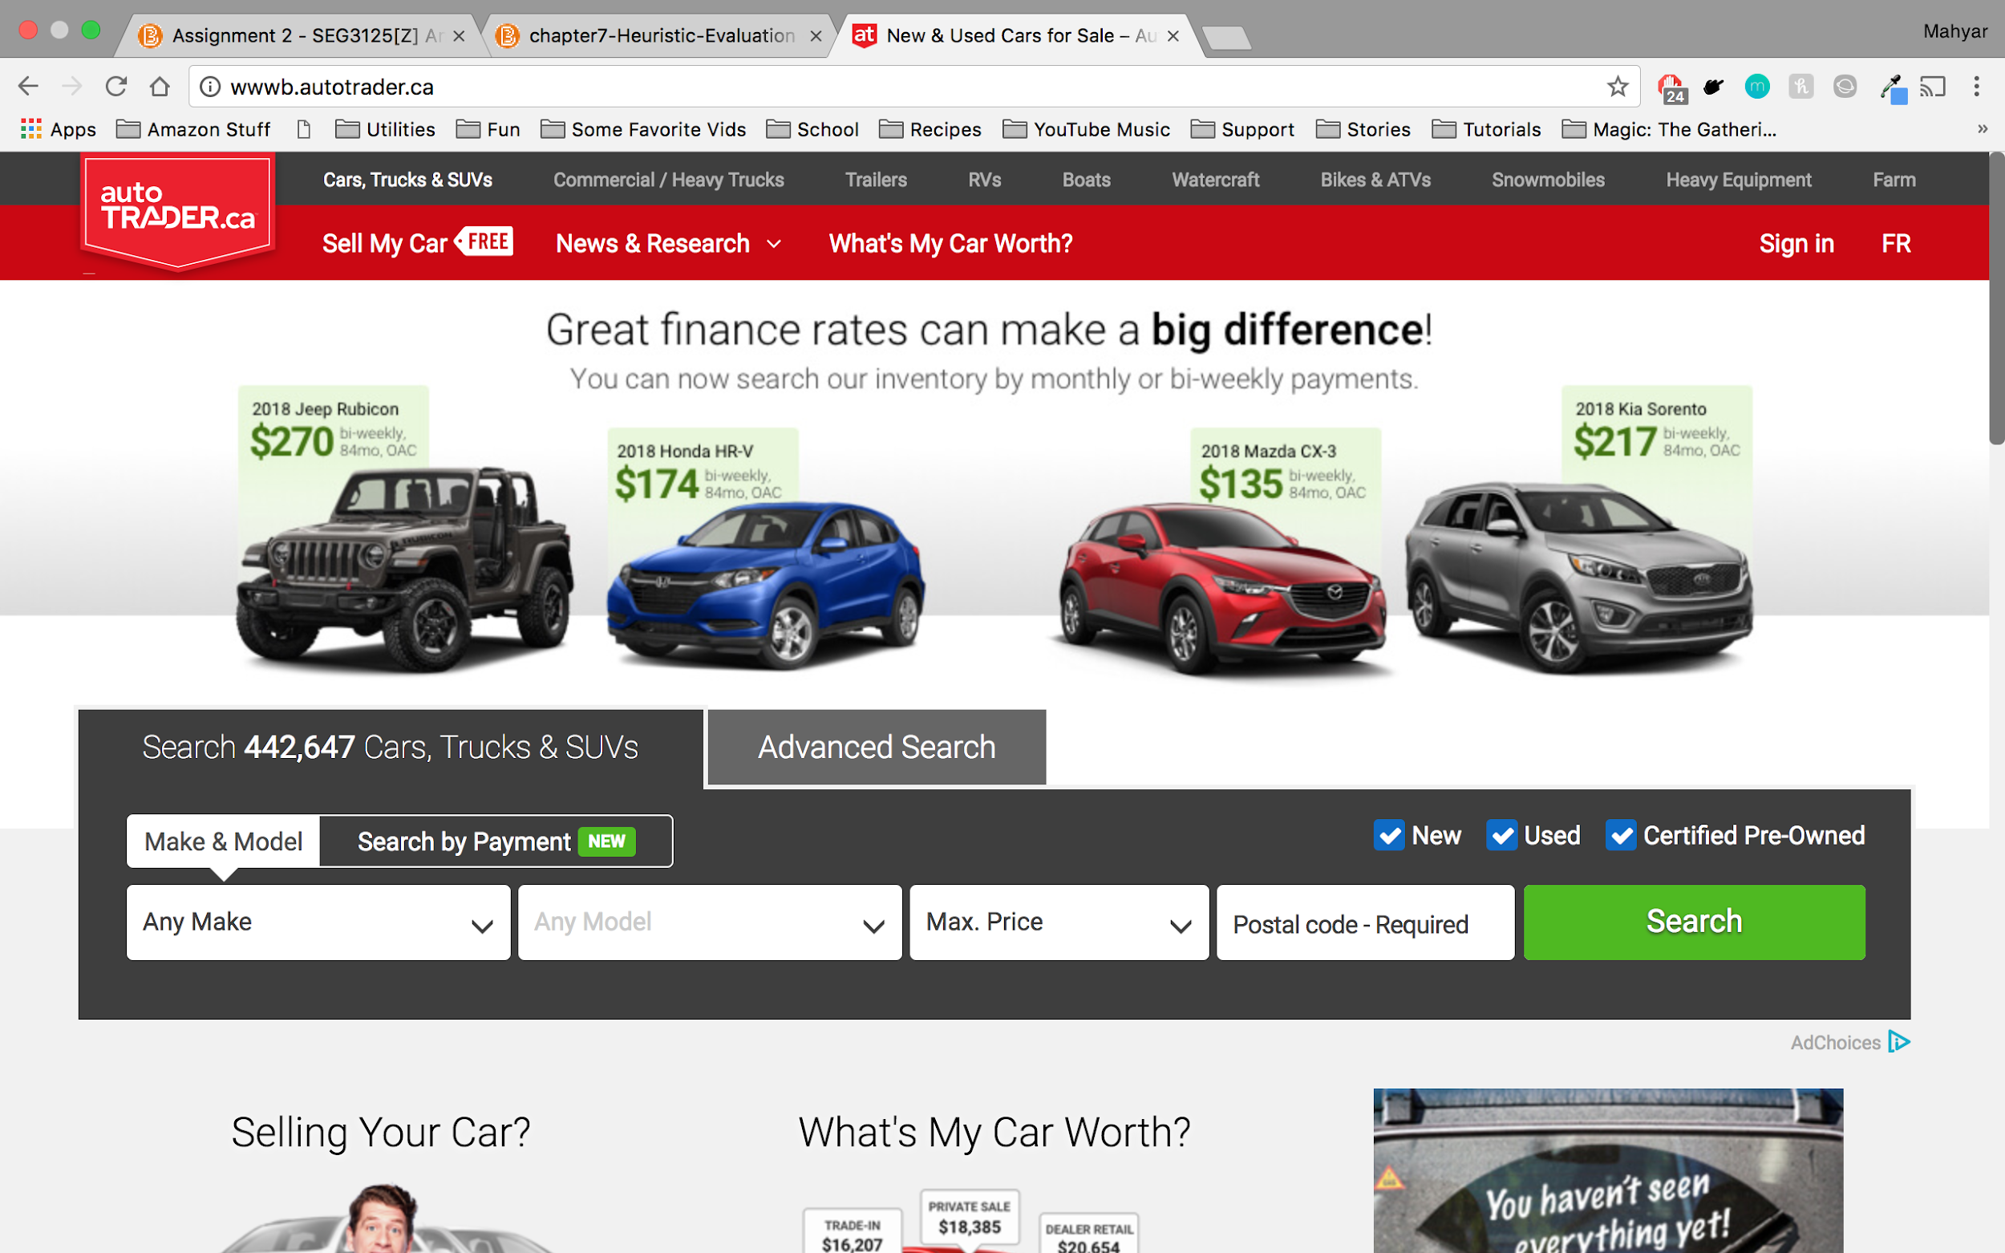

**Figure 1: Image of landing page with adblock enabled**

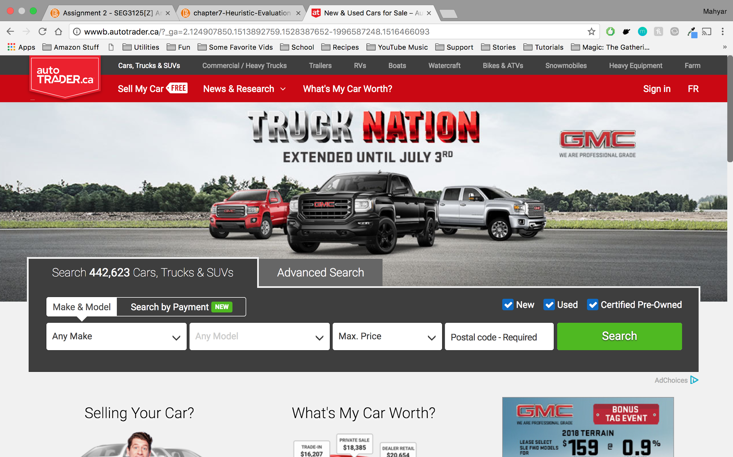

**Figure 2: Image of landing page with adblock disabled (better)**

# **Issue 2**: Error message received when logging in for the first time

**What is Problematic?**

When the user is signing up to the website with an email address, he/she is expected to validate his/her account through a link that is emailed to the user. When user clicks on the link, he/she is redirected to the main page and is asked to log in again. When attempted to log in, user receives an error message saying that “Something went wrong”. This issue will be resolved once the user refreshes the page.

**Violated Heuristics:**

* H2-5: Error prevention
  + The encountered error is a fault from the website when the user logs in for the first time after account activation
  + This error must be prevented since it does not provide a good first impression to the user
  + When the error is resolved when the page is refreshed, it contradicts the origin of the error and the error message of “Something went wrong. … Our team is in full pursuit!”.
* H2-9: Help users recognize, diagnose, and recover from errors
  + The message is expressed in plain language, however, the error message does not contain any details of what caused the error.
  + The message does not guide the user how to recover from the error. In fact, it tells them to “hang on” when the user can recover from error by refreshing the page.
* H2-7: Flexibility and efficiency of use
  + Signing up to the website itself could be a long process for regular users, and these errors make the process even longer (more clicks needed)
  + Encountering these issues makes the experience more cumbersome
  + Users who are very experienced at using computers, could try refreshing the page when encountering the received error, even when the error message does not guide them to do so. However, novice users may listen to the error message and wait for the error to be resolved or even worse, reconsider even using the website as a whole. The design of the website must cater to both inexperienced and experienced users

**Severity Rating:** 7 out of 10.

* Not a good first impression to the user
* Is not a serious issue if the user recovers from it by refreshing the page, but the website does not imply that that is possible.
* Might imply user error, granted the lack of detailed information.

**Proposed Solution:**

* Discover the root of the error
* Improve the information written in the error message such as suggesting a solution to the user to recover from error

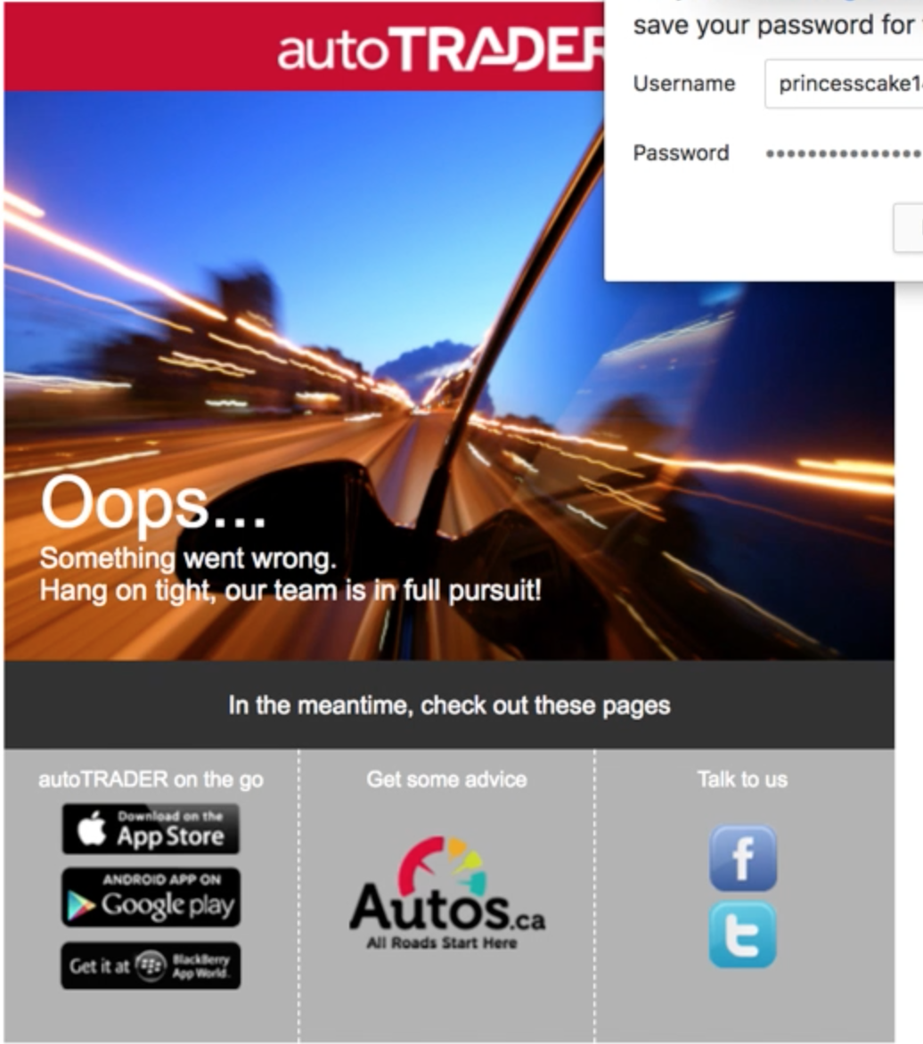

**Figure 3: Error message when logging in for the first time**

# **Issue 3**: Background UI Confusion when “X” Pressed

**What is Problematic?**

At this phase, the user has already inputted search criteria for a car, and is now at the page returned after they searched for it, in the center you will see the search results and on the left you see where you can input modifications or a new search. What the user is trying to do in this action, is input new search criteria. The issue is that, if the user presses the “X” to close the prompt, the screens background remains grey, indefinitely. This grey haze will prevent the user from clicking any links on the page if they scroll down-- the user must first either click anywhere else, or refresh the page to remove this grey haze. They have essentially made a step of closing a prompt unnecessarily cumbersome.

**Violated Heuristics:**

* H2-1: Visibility of System Status
  + It is unclear to the user when they press the “X” if they are leaving the *choosing a new search criteria* subsystem, or only leaving the *search parameter* they were updating. In addition, the user is left not knowing why the system is now grey, given there are no prompts.
* H2-5: Error Prevention
  + User should be prompted to advise why screen is grey or how to remove it if they press the “X”.
* H2-8: Aesthetic and minimalist design
  + The grey haze ruins the aesthetic while it remains after the “X” has been pressed making it difficult for users to see or read other content.

**Severity Rating:** 3 out of 10.

* It doesn’t cause any data loss, or critical issues however, it is an annoyance that could negatively affect many new users use of the system.

**Proposed Solution:**

* Autotrader should either: alert the user of why the screen is grey and how to resolve it, or when the “X” is pressed, remove the gray haze on the screen.

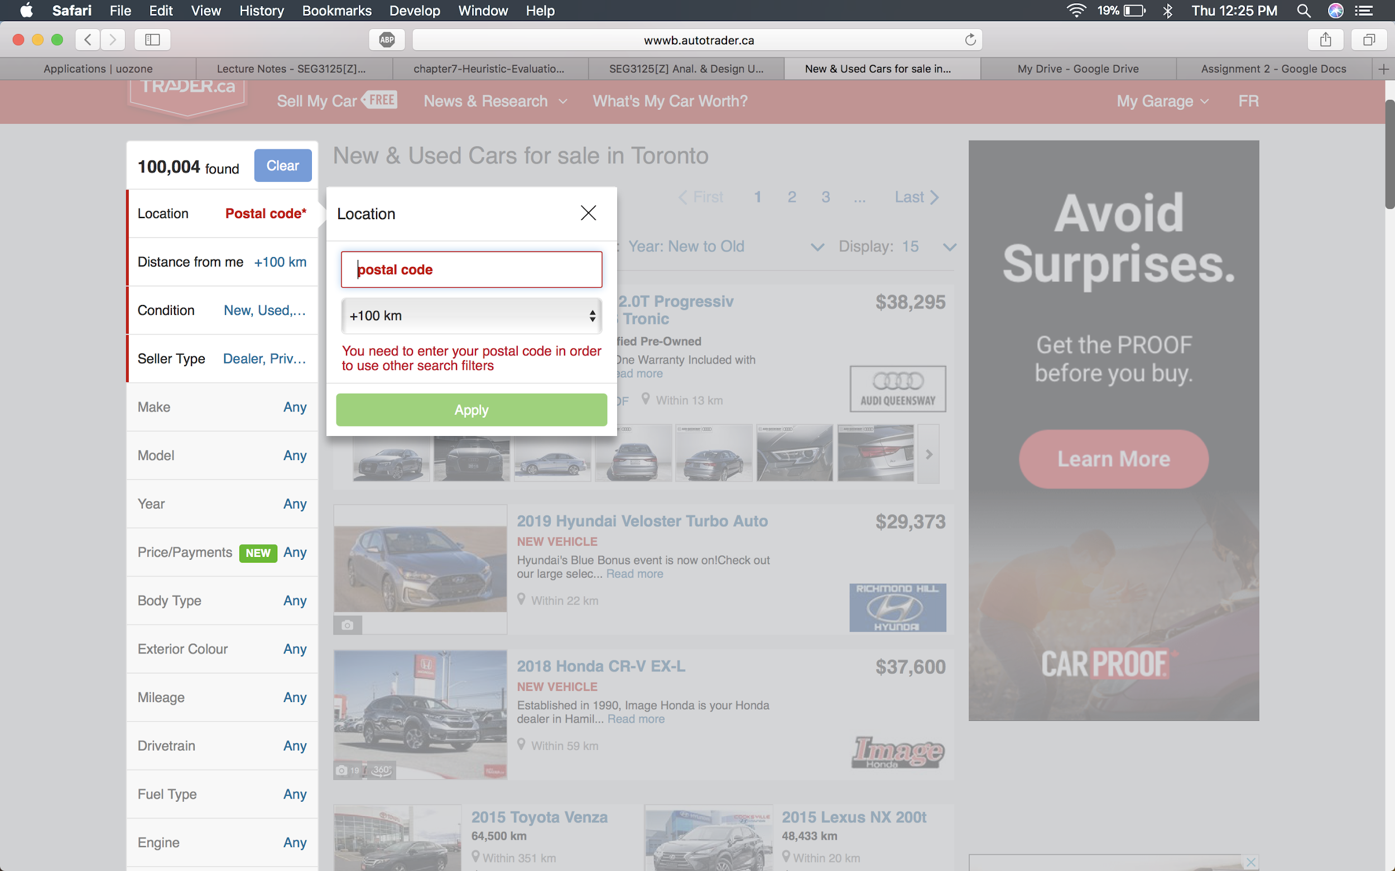

**Figure 4: Prior to Pressing the “X”**

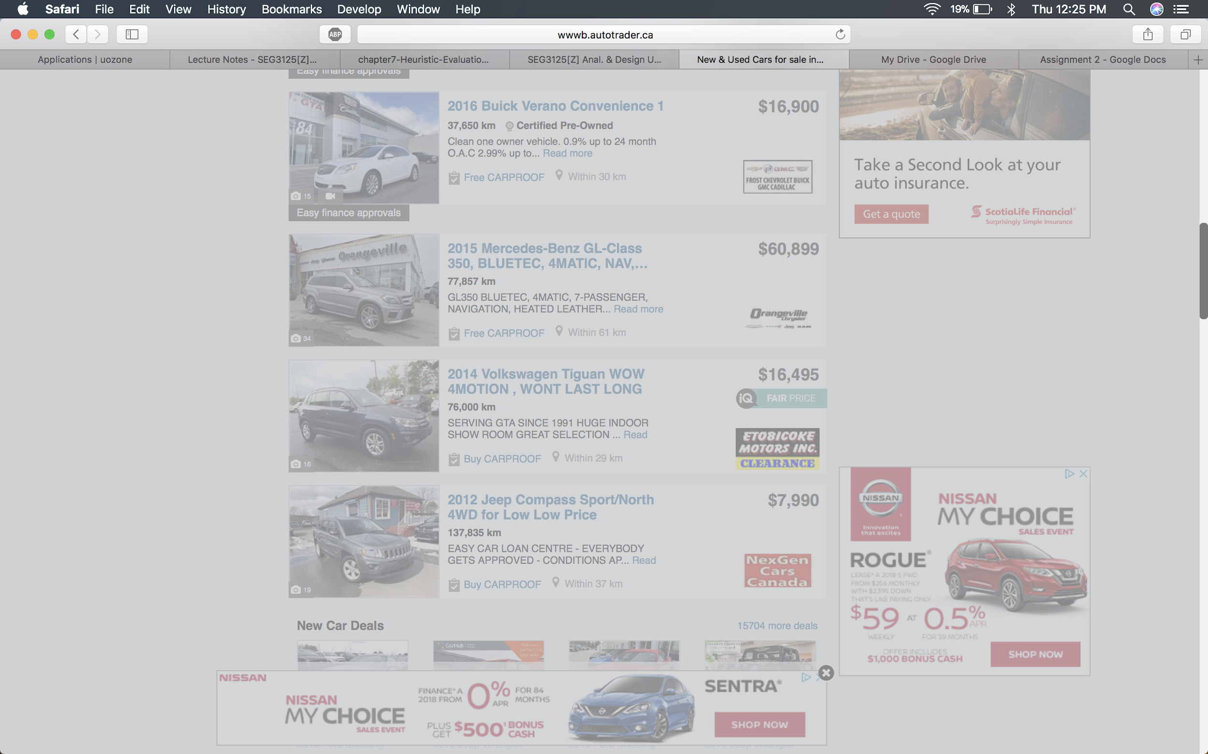

**Figure 5: After pressing the “X” - entire page remains Grey:**

# **Issue 4:** Sound Loop Problem with Videos

**What is Problematic?**

At this phase, the user has found a car they wanted to find more information on, and they had selected to look at the photo carousel of the car. This car has a video, if the user goes clicks to the video page, it auto starts. The issue is specifically how the system handles the state when a user either closes the video window by clicking out of it, or pressing the arrow in the carousel to move to the next photo. If the user either then returns to the same video-- it first, starts to play the audio from where the last video was cut off, and then secondly starts a new video with a new audio stream that will play over the other audio playing to create an audible mush of noise.

**Violated Heuristics:**

* H2-1: Visibility of System Status
  + When this issue occurs and the video playback audio is still playing, it leaves the user confused with the system’s status, given the user quit the video but it seems to still play.
* H2-9: Helps users recognize, diagnose and recover from errors
  + When this error occurs, the user is left guessing. No error messages prompt and the system provides no ways to resolve it, the user has to turn to their browser and either refresh the entire page or close the website.

**Severity Rating**: 6 out of 10

* Although this doesn’t cause any data loss, or security issue for the system-- it is a serious flaw in terms of the user experience. If a user does perform the steps above, they will see this issue, at which point the only way to resolve it is by refreshing the entire page losing search selection, or quitting the website altogether. The reason why the severity is not rated higher, is that many users may not trigger this failure from normal use.

**Proposed Solution:**

* Ideally, AutoTrader should fix the bug in their system so it fully exits out of the video once the user leaves the video page inside the carousel, so that the next time it is completely reinitiated. Temporarily, they should at least provide a prompt to explain to the user what is happening and how they can resolve it by refreshing their webpage.

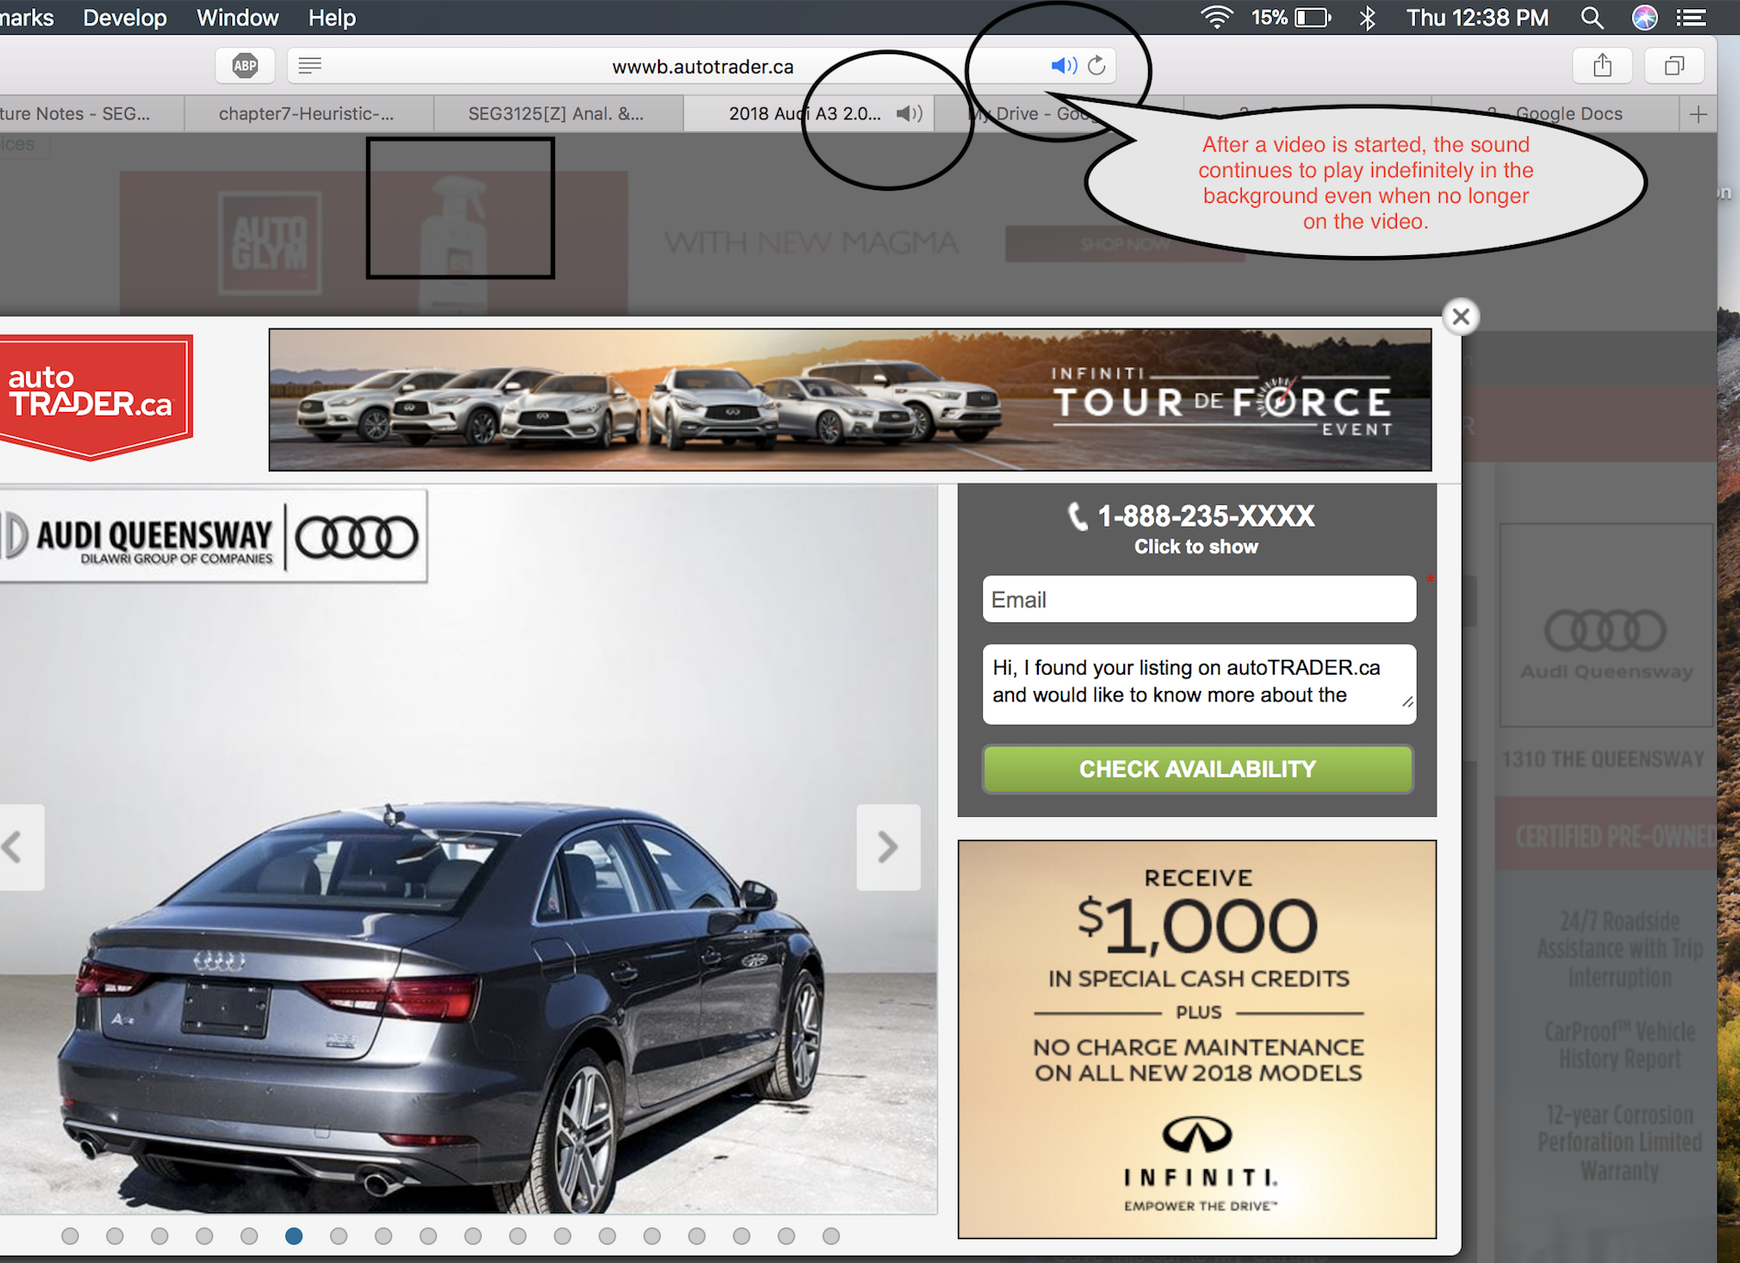

**Figure 6: Image Depicting Sound Playing In Background When Viewing an Image**

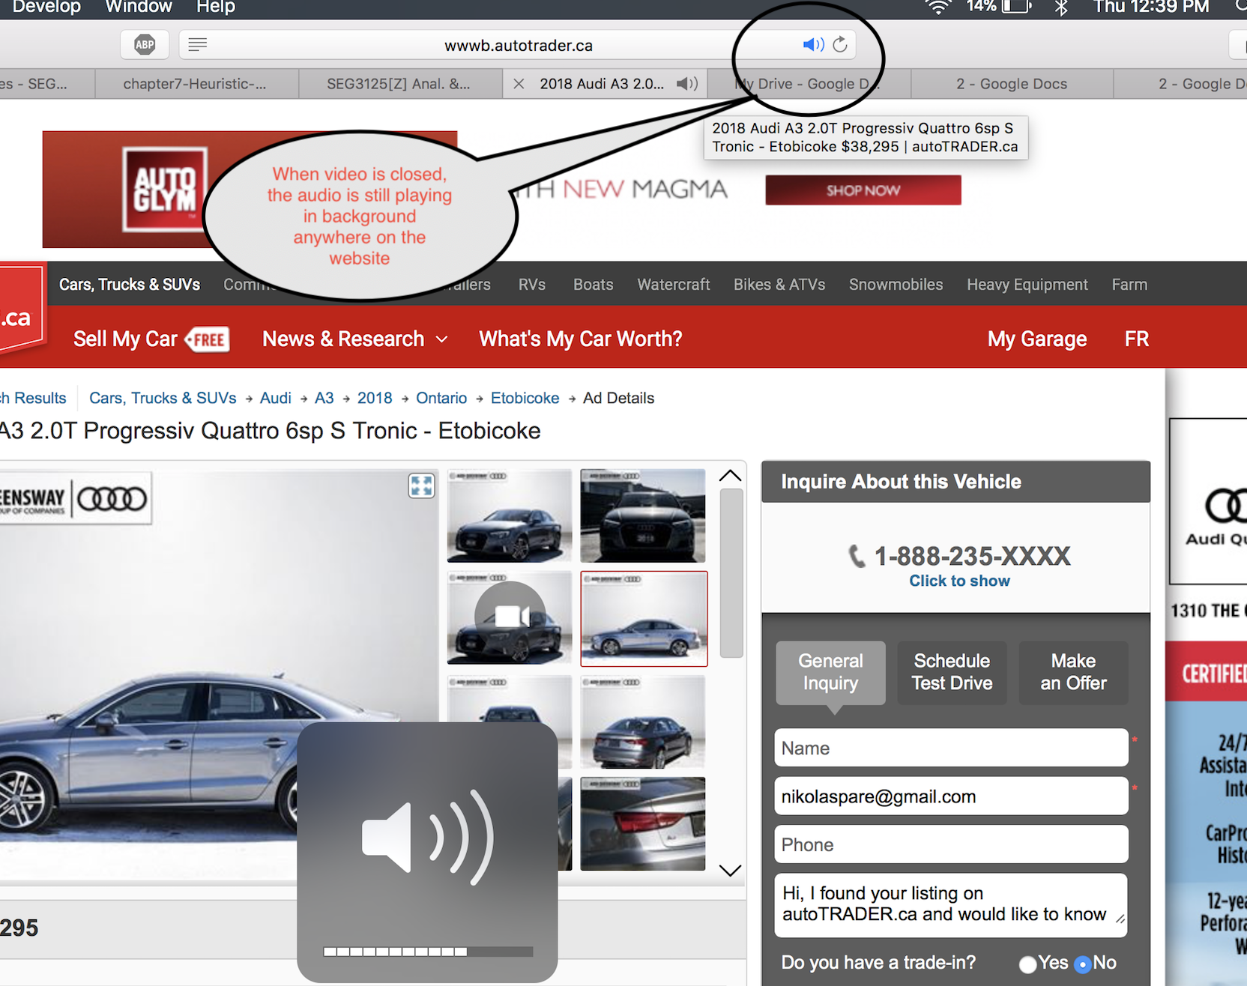

**Figure 7: Sound of Video Now Playing In Background of Website**

# **Issue 5:** Encountered issue when posting an ad

**What is Problematic?**

When the user is trying to sell his/her own car by posting an ad to the website, after entering all the necessary information such as photo of the car, price, make, model, email address, and clicking the confirmation to post the ad, he/she is encountered with a message and an email that tells the user that his/her ad was not successfully posted since because it “does not comply with [their] guidelines and therefore has been disabled”. This message does not give the exact reason the post was not posted and when tried for a second time with some changes to the information given in the post, same issue was encountered.

**Violated Heuristics:**

* H2-9: Help users recognize, diagnose, and recover from errors
  + The error message was not informative in a way that it did not tell the user what exactly went wrong during the procedure of posting an ad
  + It does not give a proper suggestion to the users toward making changes to their post.
* H2-10: Help and documentation
  + In the page where the user is preparing their ad, there is no link to the website’s “guidelines” regarding conditions of posting an ad. The document gets sent to the user once their ad is failed to follow the guidelines which is not very efficient and user friendly.

**Severity Rating:** 4 out of 10

* Not everyone may encounter this issue, but if a user does, the amount of frustration that they may experience can lead them to exit the website and try another platform to sell their car which does not build any customer loyalty and won’t receive positive reviews by the users.

**Proposed Solution:**

* Give users more details on what went wrong during the ad posting
* Give users access to guidelines in the “Sell My Car” page

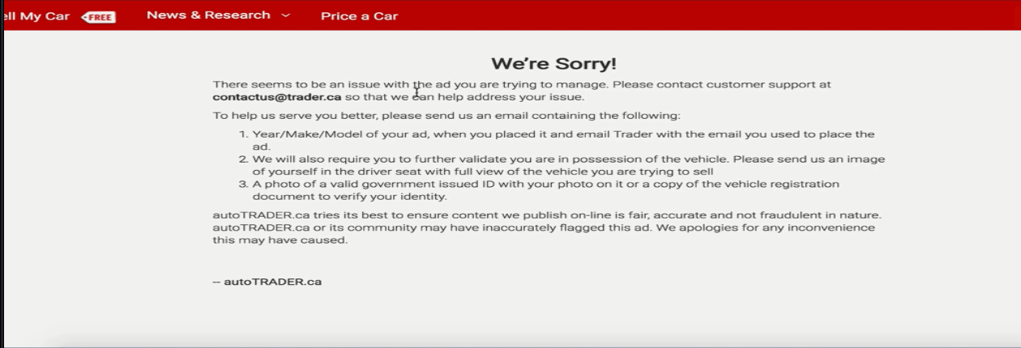

**Figure 8: Vague description of why the ad was not able to be edited.**

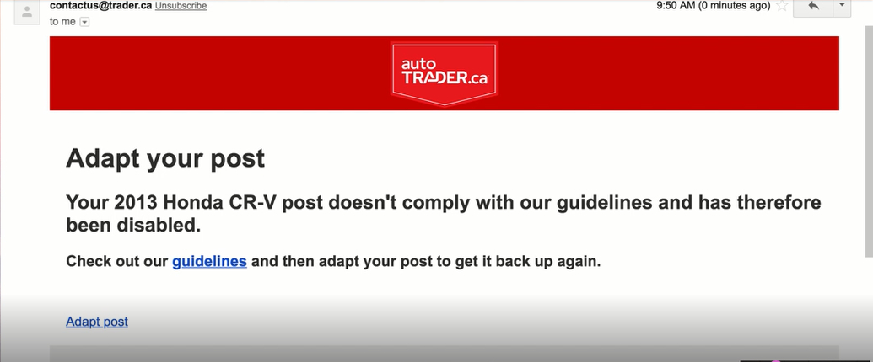

**Figure 9: Email sent to the user notifying him/her that the post was automatically deleted.**

# **Issue 6:** Only French and English Languages are Offered

**What is Problematic?**

When the user wishes to select their language, the website offers a sole button in the top right corner of the page, providing functionality to change from English to French, or from French to English. Where Autotrader, as a multi-million dollar website, fails here, is that even though the website is Canadian, there are Canadians who speak other languages other than French or English as their main language proficiency.

**Violated Heuristics:**

* H2-2: Match between system and real world
  + The website speaks only certain peoples’ languages, and completely disregards other languages that Canada’s inhabitants not only speak, but might also be more fluent in.

**Severity Rating:** 6.5 out of 10

* Not everyone may be affected by this issue, but lack of translations provided for the minority of Canada’s residents feel exclusive in nature, and would be a deterrent for these minorities from using the website.

**Proposed Solution:**

* Recognize Canada’s unofficial, but still widely spoken languages by providing more translation support, accessible through a visible and highly accessible dropdown menu.

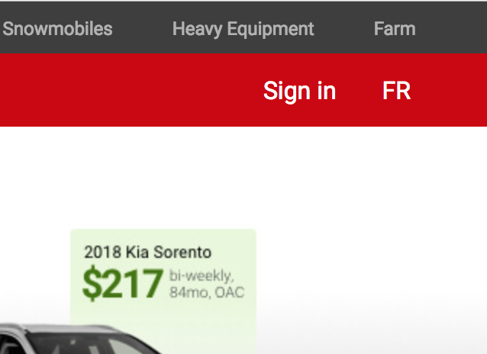

**Figure 10: English to French translation offered.**

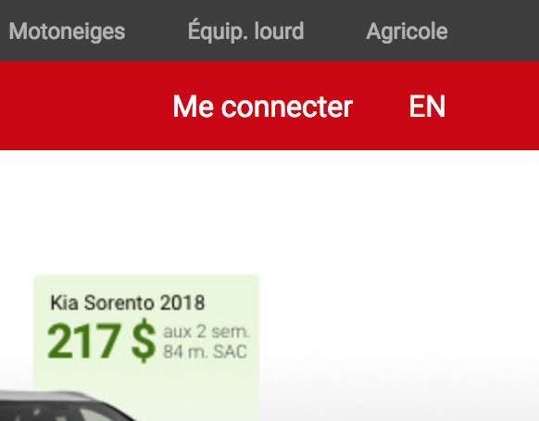

**Figure 11: French to English translation offered.**

# Conclusion

In conclusion, Autotrader violates or generally lacks common traits and features of good websites, as evidenced above.

After some thorough investigation, many issues were found that must be improved. Some issues were more minor in nature, while others were more severe had the potential to have a significant impact on the users. By improving the design of the website to follow Nielsen’s heuristics, Autotrader can improve the experience of its users and as a result build customer loyalty. This leads to more new users being attracted to use the website when planning to purchase a vehicle which results in increase of traffic on the website.